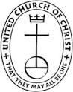
“The Visitor”
The January 2022 Newsletter of
St. John United Church of Christ - Reading

This Photo by Unknown Author is licensed under CC BY-SA

This Photo by Unknown Author is licensed under CC BY-SA

This Photo by Unknown Author is licensed under CC BY-SA

This Photo by Unknown Author is licensed under CC BY-SA

This Photo by Unknown Author is licensed under CC BY-SA

This Photo by Unknown Author is licensed under CC BY-SA

This Photo by Unknown Author is licensed under CC BY-SA
Pastor’s Page
The Christmas season in the Christian church lasts for 12 days – hence, the 12 Days of Christmas! This runs from Christmas to Epiphany, which is always on January 6th, and is the day that commemorates the arrival of the Magi in Bethlehem. You’ve probably seen this before and here is a religious tie-in to the “12 Days of Christmas” song:
2 Turtle Doves = the Old and New Testaments
3 French Hens = Faith, Hope & Clarity…the Theological Virtues
4 Calling Birds = the Four Gospels and/or the Four Evangelists
5 Golden Rings = the First Five Books of the Old Testament, the “Pentateuch”, which gives the history of a man’s fall from grace
6 Geese A-Laying = the Six Days of Creation
7 Swans A-Swimming = the Seven Gifts of the Holy Spirit, or the Seven Sacraments
8 Maids A-Milking = the Eight Beatitudes
9 Ladies Dancing = the Nine Fruits of the Holy Spirit
10 Lords A-Leaping = the Ten Commandments
11 Pipers Piping = the Eleven Faithful Apostles
12 Drummers Drumming = the Twelve Points of Doctrine in the Apostle’s Creed
The partridge in the pear tree, naturally, represents Jesus Christ.
If you don’t know what some of these are, I invite you to do a little research into them – or give me a call!
As we enter into the next season in the Christian year, the season of Epiphany, we will be looking at all the different ways that Jesus is the light of the world. Just as the Magi (or Wise Men) followed the light of the star, this season between Christmas and Lent (which starts on March 2nd this year) offer us a chance to follow the light of Christ that has come into the world. So even as the days remain more dark than light, know that the light of Christ has come into the world, and the darkness will never overcome it. If times seem dark for you, look for that light of Christ in your life, and if you need a little help from your Family of Faith, just give someone a call!
~Rev. Torie

Church Leadership Retreat
The Church Leadership Retreat is scheduled for Sunday, January 16-Monday, January 17, 2022. All church members who serve on a board or council, as well as church staff are invited to attend. All costs are covered by the church, and we will be traveling north of Columbus to the UCC Templed Hills Church Camp. If you would like to participate in this event, please sign up outside the cozy corner.

Annual Congregational Meeting
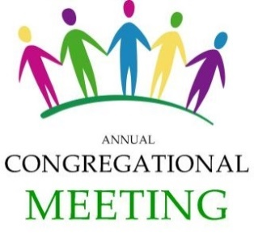
Please join us for the annual congregational meeting, which is scheduled for Sunday, January 9th, 2022 after worship. Find out what is happening around the church in the New Year, and take the opportunity to be involved in your Family of Faith!

Board of Christian Nurture
Thank you to all who went Christmas Caroling this year! Gary & Sandee Kurtz, Debbie Cummins, Ann Seebohm, Linda Simon, Bruce Koehler, Haven Reardon and Rev. Torie. Together, they brought joy and music of the season to the residents of Mt. View Terrace, Burchy & Wilma Schulte, Al Edwards, Shirley Martin, Judi Hiatt, Natalie Renacker, Walt Seebohm, Marcy Denniston, Jim Stacey, Carol Weiper, Ruth Jean Kretschmar, Ken & Rosalie Byrd, June Clifford, Julie Kadooka, and Bruce and Linda Read. Merry Christmas to all – our savior is born!
The January Lunch Bunch will be held at Skyline! It will be on Sunday, January 9th after worship. Look for a sign-up sheet outside the Cozy Corner, and join us for some church fellowship time!
Interested in playing euchre?? Every third Thursday, at 2:00pm, St. John will be hosting euchre games in the Fellowship Hall! Please feel free to join us!
The Family Retreat is coming up! It will be held March 11-13, 20 22. The theme is Resurrecting Hope! If you and your family are interested in attending, please sign-up outside the Cozy Corner to allow us to gauge interest! Thank you in advance!
**The next Board of Christian Nurture meeting is January 12th at 5:00pm**

Board of Deacons
The Make a Difference Grant is funded by the Heartland Conference of the United Church of Christ. These are small grants made to local congregations and are to be used to ‘Make a Difference’ in their communities. St. John UCC submitted a grant for open shelving in the Food Pantry and several wheeled carts to give to our neighbors who walk to get their food from us on Thursdays. We are very excited to be able to implement these changes in the Feed My Sheep program!
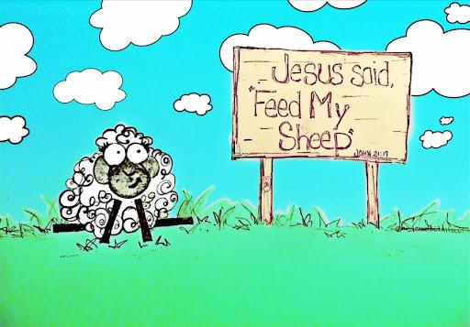
The “Feed My Sheep” program is for our community - Reading and beyond, including the beloved community of St. John United Church of Christ. Do you have a New Year’s Resolution to help out? Give Susie a call and come down on a Thursday evening to help with our drive-up food pantry!
Thank you for continuing to support all our outreach efforts during the year. Without your help, we would not have been able to give so much to the community during this Christmas season. A special thank you for Casey Kuhl, a student at Reading High School who planned a toy drive through the high school to help stuff the stockings for the children! We could not have done it without you. You are an amazing group!

Board of Elders
On Sunday, January 2nd after worship we will be taking the Christmas decorations down throughout the church. If anyone is available to help, we would love to have you!
On Sunday, January 30th we will be having a guest minister for worship. Rev. Daniel Meister is a retired UCC minister, and we are very excited to have him!
On January 9th, the traditional day to remember the Baptism of Jesus, we will be renewing our own baptismal vows. Because it has been a while since we’ve had a baptism, here is a refresher on the standard baptismal vows. These are for an infant; you can make the adjustments to make them your own baptismal vows!
Do you desire to have your child baptized into the faith and family of Jesus Christ? WE DO.
Parents, Godparents, and family: Will you encourage this child to renounce the power of evil and to receive the freedom of new life in Christ? WE WILL, WITH THE HELP OF GOD.
Will you teach this child that she may be led to profess faith in Jesus Christ as Lord and Savior? WE WILL, WITH THE HELP OF GOD.
Do you promise, according to the grace given you, to grow with this child in the Christian faith, to help this child to be a faithful member of the church of Jesus Christ, by celebrating Christ’s presence, by furthering Christ’s mission in all the world, and by offering the nurture of the Christian church so that she may affirm her baptism? WE DO, WITH THE HELP OF GOD.
Rev. Torie is offering a new Bible study this year. On the first Wednesday of the month, she will be at Northgate Park Senior Living, home of Ruth Jean Kretschmar. This Bible study may start out as a study of the gospel of Mark, or it may follow our lectionary study. If you are interested in joining that would be great! The Bible study starts at 2:30pm and is open to all residents of Northgate Park as well as members of St. John UCC.
Our AV Ministry is continuing to work on providing a high-quality live and recorded worship service for the congregation, which will be especially important during these times of many choosing to remain safely at home to worship. Thank you to Steve Culver, Michele Bunke & Cyrus Newitt for their work with our AV Ministry.
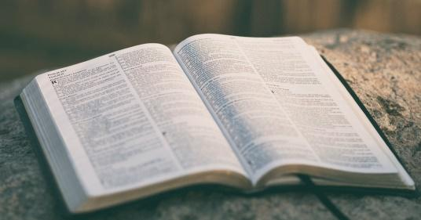
We are looking for Liturgists to serve in 2022. If you can’t commit to the whole month, please sign up for a few weeks and share with someone else. Thank you for helping to lead worship in this most meaningful way. If you’ve not been a Liturgist before, don’t let that stop you – all are welcome, and training is provided!
Greeters and Ushers are also needed for 2022 – if you like to meet people, and don’t mind arriving at church at 9:30 am, please sign up to be a Greeter! Ushers are tasked with handing out the bulletin (or placing them in the pews!) and taking up the offering. Training provided, so let us know if you are willing to help.
The Altar Flowers are a $50 gift to the church that someone, or a team of someones, makes each month. The fresh flowers add to the beauty of our worship, and bring in a bit of God’s creation to our sanctuary. If you’d like to provide the Altar Flowers for one of the upcoming months, please let the Church Office know. It’s a lovely way to make a donation in memory or honor of someone, or simply to the glory of God!
**The next Board of Elders meeting will be January 11 at 2:30pm**

Lectionary Page

Scripture | Bible Study | Sermon
Jeremiah 31:7-14  Psalm 147:12-20  Ephesians 1:3-14  John 1:(1-9), 10-18 | No Bible Study | January 2nd  **Epiphany**
Isaiah 43:1-7  Psalm 29  Acts 8:14-17  Luke 3:15-17, 21-22 | January 4th | January 9th
Isaiah 62:1-5  Psalm 36:5-10  1 Corinthians 12:1-11  John 2:1-11 | January 11th | January 16th
Nehemiah 8:1-3, 5-6, 8-10  Psalm 19  1 Corinthians 12:12-31a  Luke 4:14-21 | January 18th | January 23rd
Jeremiah 1:4-10  Psalm 71:1-6  1 Corinthians 13:1-13  Luke 4:21-30 | January 25th | January 30th

Board of Property and Finance
November: $461 | Year to Date: $9532
It’s a new year with new wishes and new projects. We are energized and empowered to tackle all the projects and issues that come before us. We are here to serve. Just let us know what you would like to see us do.
Soon we hope to present our recommendations to the congregation on the use of the funds from the Ruth Schnier estate. We are hoping that it can be used to accomplish some much needed major projects such as a new roof, restoration of the Christ ascending stained glass window, and sanctuary painting. We are gathering recommendations and cost proposals from several contractors so that we can determine what can be done and how best to proceed.
Our insurance costs have increased substantially, and we are thinking that is partly due to a lack of some important safety protocols. At the request of our insurance company, we had completed an in-depth survey which pointed to the need for us to develop and document many safety and operational guidelines for the church. Thus, we are assembling a small committee that will undertake the task of reviewing and expanding our current constitution and bylaws to include the necessary provisions that will satisfy the desires of the insurance company, and hopefully reduce our costs. This may also evolve into a written manual that details the requirements, procedures and actions that must be taken, both by employees and volunteers, to perform in a safe, efficient, and legal manner. This all helps to protect the church, its members and all who enter. If you wish to provide some input on this, please let us know. Thanks.
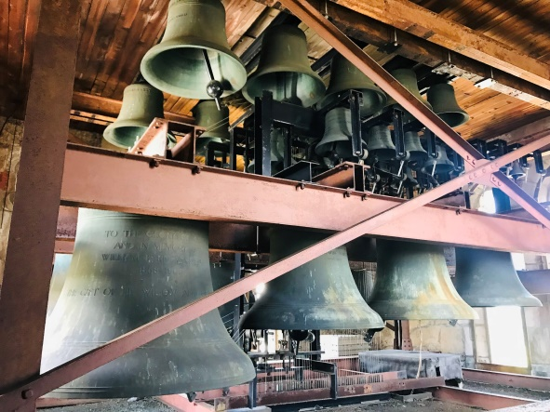
Our new carillon is performing well and spreading music and time ticks across the neighborhood. It plays some seasonal music at noon and 6:00pm every day and it chimes on the hour during the day. It can be easily programmed, is quite flexible as to what and when it can play, and it can be controlled remotely by a cell phone. Take a listen when you are nearby.
We are truly thankful for all our blessings, and we wish each and every one a very happy, productive, enjoyable, interactive, sharing, gracious, healthy, glorious and blessed New Year.
**The next board of Property & Finance Meeting is January 11 at 5:00pm**

Men’s Group
The Men’s Group is resuming regular monthly meetings, typically on the 1st Monday of each month, at 6:00pm. A meal is provided, and we plan fundraises and service projects for the church and community.
Men of the church, as well as friends of the church are encouraged to participate. There is strength in numbers and we gain strength and energy from each other!

Upcoming plans include:
- German Heritage Dinner: March 26th: This is our fundraiser for the Bob Christophel Memorial Scholarship
- Dart Night & Bed Making Service Project: targeted for early 2022
This is a great time to get involved with the Men’s Group! Please contact Steve Culver (513-262-7471) with any questions!
**The next Men’s Group Meeting is January 3rd at 6:00pm**

Member Outreach
At a recent Men’s Group meeting, it was agreed to offer the following services to our church members:
- Handyman Services: If you need any assistance with a handyman or clean-up type projects, please contact us. We will do our best to find a convenient time to assist.
- Computers Looking for a Good Home: Through a member’s resources, we have a number of gently used computers that are available for use. If you are in need of a Windows-based computer, please let us know and we can help with delivery and set-up.
Please contact: Gary Kurtz 513-446-5827 | Steve Culver 513-262-7471

January Birthdays and Anniversaries

Birthdays
Jan 1 Natalie Renaker
Jan 9 Don Apking
Jan 10 Emily Hogeback
Jan 13 Jean Kretschmar
Jan 15 Rev. Torie Front
Jan 21 George Clary
Jan 22 Jane Hendrix
Jan 23 Kathy Bentley
Jan 24 Gary Kurtz

Anniversaries
Jan 10 Joe and Amy Clay

January Prayer Requests
Prayers For Those Facing Risks:
For front line workers
For those in the path of violence or drug and other addictions
For the homeless
For all who suffer with depression and sadness
For all our military and veterans
For our country
For al those in Bowling Green, Kentucky who were affected by the tornado
Prayers For Our Friends Suffering From Illness or Facing Surgery:
For Donnie Sanders, Ruthie’s brother
For Carol Nieman
For Sue, Mike, Doug, Tracy & family
For Phil Hauenstein
For Albert, Ann’s brother
For Kirk Gay, Barbara Gibler’s cousin
For Eddie & Doris
For Rebecca
For Dustin, Judi M.’s grandson
For Carol & Dave Hall
For the Kurtz Family
For Bruce & Susie’s Family
For Alaska & Brad
For Daniel H.
For Chuck, Scott’s friend
For Ken Byrd
For Estelle, who moved to the Alois Alzheimer Center
For Helen & Katie
For Mike, Judi’s son who had a recent knee surgery
For Ron, Bob’s brother
For Bob
For Nancy, Rev. Torie’s mother
Prayers Of Praise and Joy:
Hallelujah for the bells of good ol’ St. John
Prayers For Those Who Have Lost Loved Ones:
For the family of Joe Pasqualetti

