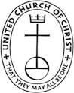
“The Visitor”
The December 2021 Newsletter of
St. John United Church of Christ - Reading

This Photo by Unknown Author is licensed under CC BY-SA

This Photo by Unknown Author is licensed under CC BY-SA

This Photo by Unknown Author is licensed under CC BY-SA

This Photo by Unknown Author is licensed under CC BY-SA

This Photo by Unknown Author is licensed under CC BY-SA

This Photo by Unknown Author is licensed under CC BY-SA

This Photo by Unknown Author is licensed under CC BY-SA
Pastor’s Page
Jesus, our Lord and Savior, has been given many names – in the Bible and throughout the ages, including these:
- Emmanuel
- Christ
- Lord
- Master
- Logos (the Word)
- Son of God
- Son of Man
On our Advent Sundays, we will look at a different name for Jesus each week: Emmanuel, Prince of Peace, Christ, and Lamb of God. This Advent season is a time of preparation, and looking at the different names for Jesus seems like a good way to ponder the mystery of the Christ Child. What other names for Jesus do you like to use? Perhaps ‘name’ isn’t the right word, perhaps it’s ‘title’. I encourage you to think about this as we move through these next four weeks. As we use these four weeks leading up to Christmas to prepare for the birth of our Savior, may the Advent themes of hope, peace, joy, and love fill your Spirit. Amen.
~Rev. Torie

Board of Christian Nurture
Interested in playing euchre?? Every third Tuesday, at 2:15pm, St. John will be hosting euchre games in the Fellowship Hall! Please feel free to join us!
This winter, our Faith Formation focus will be on teaching our kids various Bible stories. If you have kids in your family that you’d like to introduce to Daniel and the Lion’s Den or David and Goliath, bring them to church with you! After the Children’s Chat, the kids will be taken out for their special Faith Formation time. And, if God is nudging you to help tell these stories to the kids, please see Haven Reardon. We are looking for volunteers on a rotational basis, so you wouldn’t have to help out more than one Sunday a month. Can you remember your first Sunday School teacher, the one who brought the Bible stories alive for you? This could be YOU for one of our kids!!
This year’s Christmas Extravaganza will be held on Sunday, December 12th! Everyone is welcome! Dinner is free, but please bring a wrapped ornament for the gift exchange! Sign up now outside the Cozy Corner or by calling the church office!
It is time for Christmas Caroling! This year will be spreading Christmas cheer on multiple dates: Tuesday, December 14th at 10:00am, Wednesday, December 15th at 3:00pm and Sunday, December 19th at 11:00am. We have many homebound and elderly members who look forward to our caroling, and by breaking this event into three different dates, we hope to reach as many people as possible, singers included. The more the merrier, please sign-up outside the Cozy Corner!
White bags for the month of November and December will be combined. Please expect these to be delivered around December 2nd-4th.
Save the date – March 11-13, 2022 will be the Family Retreat!
**The next Board of Christian Nurture meeting is December 1st at 4:30pm**
Board of Deacons
Hello and Merry Christmas from the Deacons!
We thank you for your generous donations. We were able to provide 55 Thanksgiving bags to our neighbors and some of the congregation. You also donated $975 in gift cards for Hope Emergency! Your generosity is overwhelming.
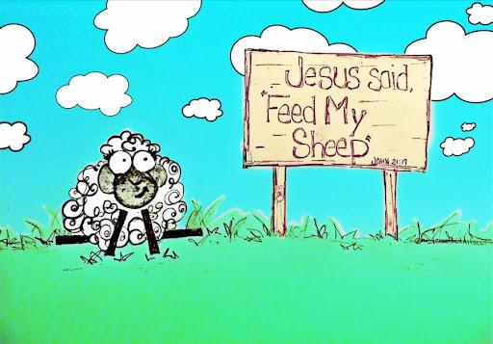
If you need some help with food for your Christmas meal, or anytime you need a bag of groceries, please contact Rev. Torie or Susie Koehler. The “Feed My Sheep” program is for our community - Reading and beyond, including the beloved community of St. John United Church of Christ.
There are some families that participated in our “Feed My Sheep” program who could use some help with Christmas presents this year. Rev. Torie has the information for each child and what they need, please see her if you are interested in doing some Christmas shopping for someone in need! Perhaps, you are a part of a group at church - Bible study, choir, a board - and you’d like to pool your money and go together to buy a gift or two!
For several years we have given Christmas stockings to children that come to our pantry on Thursdays. This year, the stockings were created by the ladies of Missionary Sewing! We will be collecting small toys and Christmas candy in December. There will be a bin on the second floor for donations.
The Deacons are starting to think about spring mission trips! More on that later.
Thank you for continuing to support all of our outreach efforts during the year. We could not have done it without you. You are an amazing group!

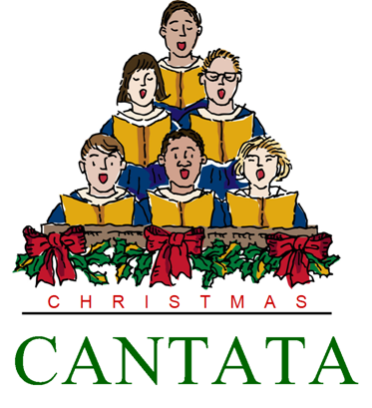
Board of Elders
December 5th is Cantata Sunday! Please join us for a morning of music, featuring a 9-piece orchestra under the baton of our own music director, Debbie Cummins! Everyone is welcome to enjoy the Christmas story in music and song during our weekly worship!
Advent Season Worship Schedule:
- December 14th 10:00am: Christmas Caroling
- December 15th 3:00pm: Christmas Caroling
- December 19th 11:00am: Christmas Caroling
- December 16th 6:00pm: Blue Christmas - light a candle for loved ones
- December 21st 2:15pm: Euchre in the Fellowship Hall
- December 24th 4:00pm & 10:00pm: Christmas Eve Worship
- December 26th: Boxing Day Sing-A-Long
Our AV Ministry is continuing to work on providing a high-quality live and recorded worship service for the congregation, which will be especially important during these times of many choosing to remain safely at home to worship. Thank you to Steve Culver, Michele Bunke & Cyrus Newitt for their work with our AV Ministry.
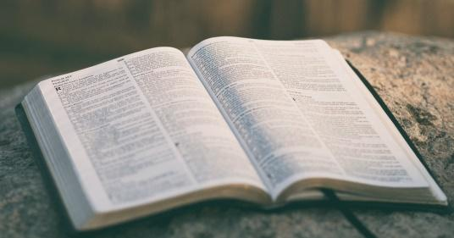
We are looking for Liturgists to serve in 2022. If you can’t commit to the whole month, please sign up for a few weeks and share with someone else. Thank you for helping to lead worship in this most meaningful way. If you’ve not been a Liturgist before, don’t let that stop you – all are welcome, and training is provided!
Greeters and Ushers are also needed this Winter – if you like to meet people, and don’t mind arriving at church at 9:30 am, please sign up to be a Greeter! Ushers are tasked with handing out the bulletin (or placing them in the pews!) and taking up the offering. Training provided, so let us know if you are willing to help.
The Altar Flowers are a $50 gift to the church that someone, or a team of someones, makes each month. The fresh flowers add to the beauty of our worship, and bring in a bit of God’s creation to our sanctuary. If you’d like to provide the Altar Flowers for one of the upcoming months, please let the Church Office know. It’s a lovely way to make a donation in memory or honor of someone, or simply to the glory of God!
**The next Board of Elders meeting will be December 2nd at 2:30pm**

Lectionary Page
Scripture | Bible Study | Sermon
Baruch 5:1-9  Luke 1:68-79  Philippians 1:3-11  Luke 3:1-6 | November 30th | December 5th  *2nd Sunday of Advent – Peace*  Name of Jesus: Prince of Peace  Cantata Sunday
Zephaniah 3:14-20  Isaiah 12:2-6  Philippians 4:4-7  Luke 3:7-19 | December 7th | December 12th  *3rd Sunday of Advent – Joy*  Name of Jesus: Christ
Micah 5:2-5a  Psalm 80:1-7  Hebrews 10:5-10  Luke 1:39-55 | December 14th | December 19th  *4th Sunday of Advent – Love*  Name of Jesus: Lamb of God
1 Samuel 2:18-20, 26  Psalm 148  Colossians 3:12-17  Luke 2:41-52 | December 21st | December 26th  *Christmas Carol Sing-A-Long*
Isaiah 60:1-6  Psalm 72:1-7,10-14  Ephesians 3:1-12  Matthew 2:1-12 | No Bible Study | January 3rd  *Epiphany*

Board of Property and Finance
October: $194 | Year to Date: $9071
December is always a busy month for us, as we are sure it is for you also. Along with all the preparations for Christmas and other holiday events, we work on such things as budgets for next year, insurance renewals, heating problems, mice intrusions, year-end needs, and heaven forbid...snow removal and salting.
We have prepared a budget for 2022 that will be presented to the Church Council for their review and approval. As in the past, it will need the support of the Memorial Endowment to meet our goals. We thank them so much for their help in assembling the budget.
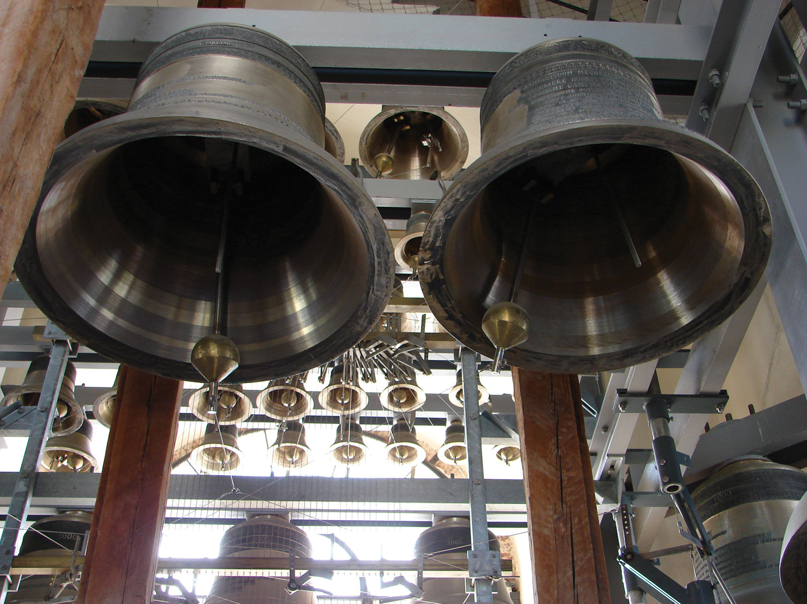
Our new electronic carillon has arrived and is operating. We get 30 days to listen and work with it to decide if this will be a good match for us. Along with ringing out into the neighborhood, it can be controlled remotely, can play chimes for special occasions, and can also chime the hour if we so decide. We will coordinate our chiming with St. Paul Lutheran Church so that we are not stepping on each other’s bells. Take a listen when you are nearby.
Rick Caudill has been working on replacing the rotten wooden outside window sills on the eight stained glass windows that flank the sanctuary. He is replacing them with aluminum pieces that are durable and will last for a long time. He has the skills and we thank him for doing this work. In addition, workers have been tuck pointing the brick on the south wall of the sanctuary. This involves cleaning and filling all the brick joints with new mortar which helps to prevent water intrusion and subsequent damage to our interior walls. This work will continue next spring when the warm weather returns.
We have been blessed to receive so many donations from so many people towards many of the projects and missions of our church. We have been graced with a substantial donation from the estate of one of our members who recently passed. When these monies come to us, we are hopeful that this donation will help to support these projects and missions. Have you thought about including St. John UCC in your estate plans? It’s never too early to have this discussion. It’s a wonderful way to continue to support the church that supports you now, in the future!
Our church again served as a polling location for the November elections. The Fellowship Hall has been a voting location for many years, and we are pleased that it can serve that purpose.
Thanks so much to all board and council members, especially our Property & Finance members. They serve joyfully and put in the time, the effort and the heart to make sure that our staff are happy and efficient, and that our facilities and funding support our service to our members, our community and to our Lord and Savior.
We are truly thankful for all our blessings, and we wish each and every one a very joyous, meaningful and merry Christmas.
**The next board of Property & Finance Meeting is December 14th at 5:00pm**

Men’s Group
The Men’s Group is resuming regular monthly meetings, typically on the 1st Monday of each month, at 6:00pm. A meal is provided, and we plan fundraises and service projects for the church and community.
Men of the church, as well as friends of the church are encouraged to participate. There is strength in numbers and we gain strength and energy from each other!
Upcoming plans include:
- Year End Party: December 5th 6:00pm-9:00pm at Reading Eagles: A popular annual event of fun, games and fellowship. The cost is $10/person. If you have participated in the past, invite a buddy to join you. If it is new to you, we will welcome you with open arms!
- German Heritage Dinner: March 26th: This is our fundraiser for the Bob Christophel Memorial Scholarship
- Dart Night & Bed Making Service Project: targeted for early 2022
This is a great time to get involved with the Men’s Group! Please contact Steve Culver (513-262-7471) with any questions!
**The next Men’s Group Meeting is January 3rd at 6:00pm**

Member Outreach
At a recent Men’s Group meeting, it was agreed to offer the following services to our church members:
- Handyman Services: If you need any assistance with a handyman or clean-up type projects, please contact us. We will do our best to find a convenient time to assist.
- Computers Looking for a Good Home: Through a member’s resources, we have a number of gently used computers that are available for use. If you are in need of a Windows-based computer, please let us know and we can help with delivery and set-up.
Please contact: Gary Kurtz 513-446-5827 | Steve Culver 513-262-7471

Church Leadership Retreat
The Church Leadership Retreat is scheduled for Sunday, January 16-Monday, January 17, 2022. All church members who serve on a board or council, as well as church staff, are invited to attend. All costs are covered by the church, and we will be traveling north of Columbus to the UCC Templed Hills Church Camp. If you would like to participate in this event, please sign up outside the cozy corner.
December Birthdays and Anniversaries

Birthdays
Dec 11 Sue Meyer
Dec 12 Marlin Fuchs

Anniversaries
Dec 10 Robert & Jeanette Wiley
Dec 31 Melissa & Rob Harman

December Prayer Requests
Prayers for those facing risks
For front line workers
For those in the path of violence, or drug and other addictions
For the homeless
For all who suffer with depression and sadness
For all of our Veterans

Prayers for our friends suffering from illness or facing surgery
For Donnie Sanders
For Carol Nieman
For Linda Read
For Sue, Mike, Doug, Tracy and family
For Virgie & Bob Cutter
For Phil Hauenstein
For Anna Bunke, who continues to battle cancer
For June, Linda’s mom
For Ann’s brother, Albert
For Barbara Gibler’s cousin, Kirk Gay
For Ruthie’s brother, Bill
For Eddie & Doris
For the Kurtz Family
For Dustin
For Tim, Susie & Bruce’s son-in-law
For Jim McGuire
For Carol & Dave
For Daniel and his family
For Ken Anders
For Jan Godwin & family
For Barbara Gibler
For Bob Woofruff, a friend of Jim Bunnings
For Michael Horsley, Rosalie Byrd’s son
For Marlin Fuchs
For Sue Hicks

